# Activity and posture recognition using smartphones (NoBackpain challenge)

Day 1 : Explanation of project and introduction to tools that are going to be used

## Context:

Chronic low back represents one of the major causes of disability worldwide. It is defined as pain that continues for 3 months or longer in the lower back. Assessing physical activity (PA) is of important clinical value for patients with low back pain (LBP). Patients with low back pain present low PA levels.

* People with chronic low back pain: difficulty in performing low-intensity physical activities. The most affected are:

1. Household activities
2. The kitchen
3. Work
4. Prolonged sitting position
5. Prolonged lying down (sleeping)

* People with chronic low back pain have a level of activity that fluctuates throughout the day: very active in the morning, much less in the evening.

## Objective

Evaluate a smartphone-based measuring system of physical activity and posture during daily life. This tool permits clinicians to give subject-specific treatments. The system must classify physical activity into static, walking, dynamic and sports/high intensity, classify posture into sitting, lying, standing and then give a report of how much time the patient spends in each posture and activity. The classification tree and example of report is given in figure 1 below.

|  |  |  |  |  |  |
| --- | --- | --- | --- | --- | --- |
| Activity daily life | | | | | Sports |
| Static | | | Dynamic | |
| Standing | Sitting | lying | Walking | other |
| 1h | 1h | 6h | 1h | 4h | 0.5h |

Figure 1: classification tree and example of clinical report.

## How clinicians classify daily activities?

Here is a table of how clinicians categorize daily activities.

|  |  |  |
| --- | --- | --- |
| Static | Dynamic | High intensity |
| Lying  Sitting  Standing  Watching Tv  Folding laundry  Ironing  Computer work  Car driving  Brushing teeth  Eating  Washing dishes | Vacuuming  House cleaning  Sweeping  Walking | Skiing  Jogging  All other sports… |

## Material and methods

In this project we are going to use machine learning to classify posture and activities. Machine learning can be explained through figure below.

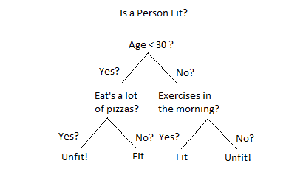

To create a machine learning algorithm, we need a dataset! To create a dataset, we need a measuring tool. Your smartphone!

## Application to record Inertial data:

**This application is made for android devices**

**If you have an Iphone 🡪 you will get either the smartwatch or an inertial sensor or another spare smartphone (we have three alternatives)**

Link to download: <https://drive.google.com/file/d/1Ve3aoEQ3isfU9ypa01i4zCClSYZwra37/view?usp=sharing>

Before clicking the link: Enable your Android to install unknown apps.

Go to Settings > Apps > Menu > Special access. Choose Install unknown apps.

Add activity and then click start recording

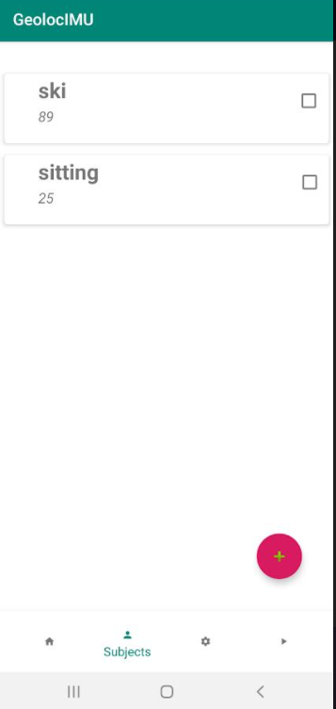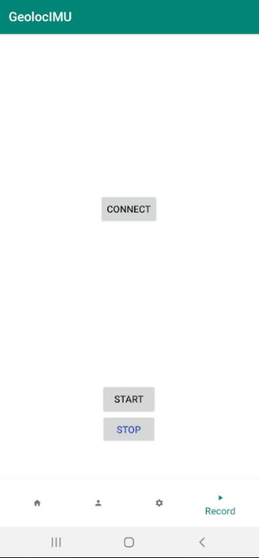

Files are both saved on your phone and if your phone is connected to the internet they are sent to this link: [https://console.firebase.google.com/u/0/project/seminarlauzet/storage/seminarlauzet.appspot.com](https://console.firebase.google.com/u/0/project/seminarlauzet/storage/seminarlauzet.appspot.com/files/~2F)

Note: if you are trying it and you do not have access to the link now it is okay!

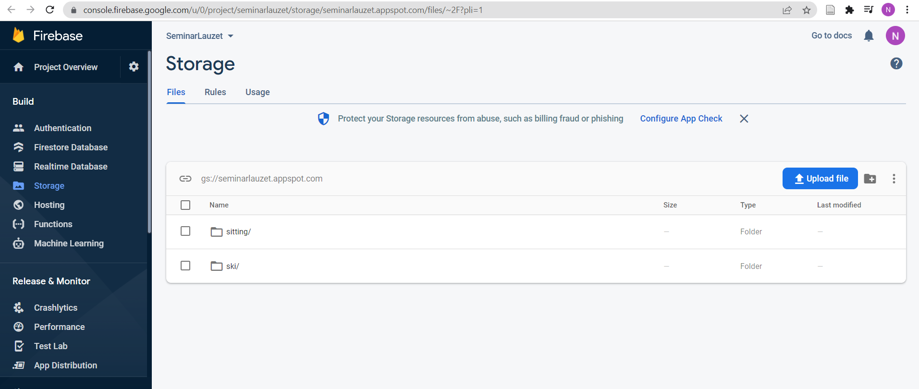

For each activity you can find acceleration, gyroscope, magnetometer files:

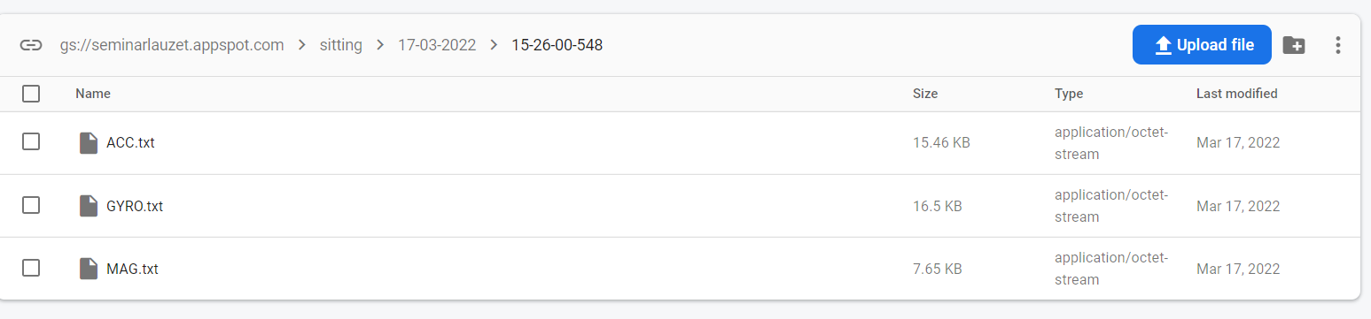

**You can find them on your phone in**

My files->Internal storage->GeolocIMU_logger->Ski(activity)->date of the day->time of the day->

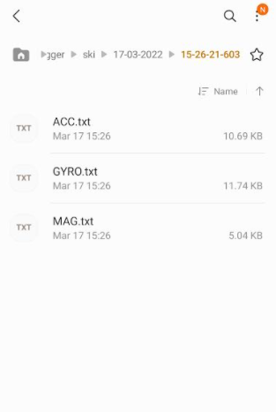

## Code to view data recorded:

In this project we are going to use python. You can use whatever python IDE/ software. If you do not have anything installed you can use: **google colab but to run code you will need to have internet connection**

[**https://colab.research.google.com/**](https://colab.research.google.com/)

**A better option is to install something like anaconda and use Jupyter notebook which is perfect!** [**https://www.anaconda.com/**](https://www.anaconda.com/)



**If you don’t have time to download it, I will give you the .exe file at the time of seminar!**

**And for those who are worrying about python coding!**

**Don’t worry you do not need to be a pro python coder to participate!** Blocks of code are already available in this link below <https://github.com/Naima96/Lauzet.git>

### Dataset collection:

Sensor placement: pants pocket

Divide yourselves into three subgroups: 1 group static +sport, 1 group dynamic +sport, 1 group testing dataset.

1. Training dataset: (checklist)

|  |  |  |
| --- | --- | --- |
| Static/ posture | Dynamic | Sport |
| * Lying 1 (3 min) * Lying 2 (3min) * Sitting (3 min) * Eating (3min) * Standing (3 min) * Washing dishes (3 min) | * Vacuuming (6 min) * Sweeping (6 min) * Walking (6 min) | * Skiing (6min) * Hiking (6 min) * …. |

1. Testing dataset:

**Record continuous daily activity for ~ 3 hours** and **label it.**

### Analysis of data and feature calculation:

Link to code: <https://github.com/Naima96/Lauzet>

We need to find features in signals that can help us determine the activity/posture.

Open notebook feature_calculation.ipynb

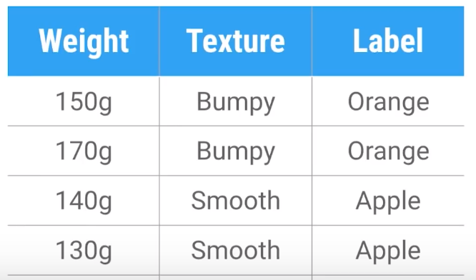

**X**

**Y**

We use sliding window to calculate features**: 3 second window and 50% overlap**

**Save the data calculated!**

### Machine learning model

Link to code: <https://github.com/Naima96/Lauzet>

Open notebook training_model.ipynb

Evaluation of model:

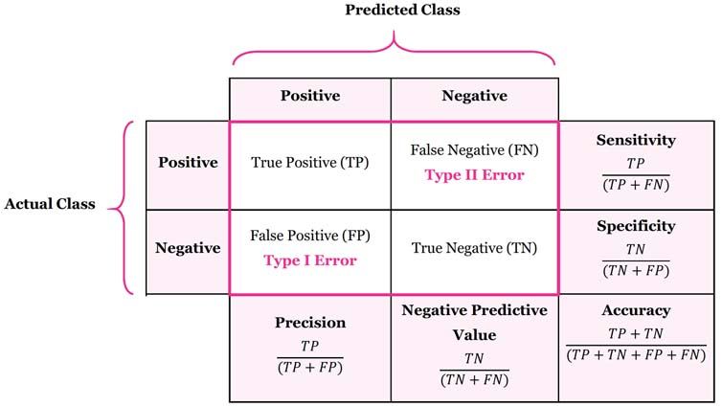

**If we think the model is ready to be used. Save it so we try it on the testing dataset!**

Day 3

## Results:

Give the confusion matrix of how the model performed on the three hours testing data.

Someone should write the results and do a presentation.

## Perspective and if we have more time

Increase the dataset to improve the model